Managing PetStore Using REST

This REST PetStore sample shows how to use the RESTful service to add, delete, update, and retrieve Pet information from a PetStore.

The Schema definitions for this sample is generated from a PetStore Swagger document obtained from http://petstore.swagger.io/v2/swagger.json and the implementation is a subset of PetStore application hosted at http://petstore.swagger.io/.

This sample uses the following HTTP methods for the Pet REST Resource:

* POST: Add a Pet to the PetStore
* GET: Get a Pet from the PetStore
* PUT: Update a Pet in the PetStore
* DELETE: Delete a Pet from the PetStore

**Prerequisites**

Install the latest Google Chrome version in the standard default location.

PetStore Service Application

In this process, the Rest service is configured to perform four operations, POST, GET, PUT, and DELETE.

**Running the PetStore Service Application**

To run the PetStore service processes from the Process Editor, follow these steps:

1. Click on the Post
2. Provide Json/Xml payload
3. Click on Try it out

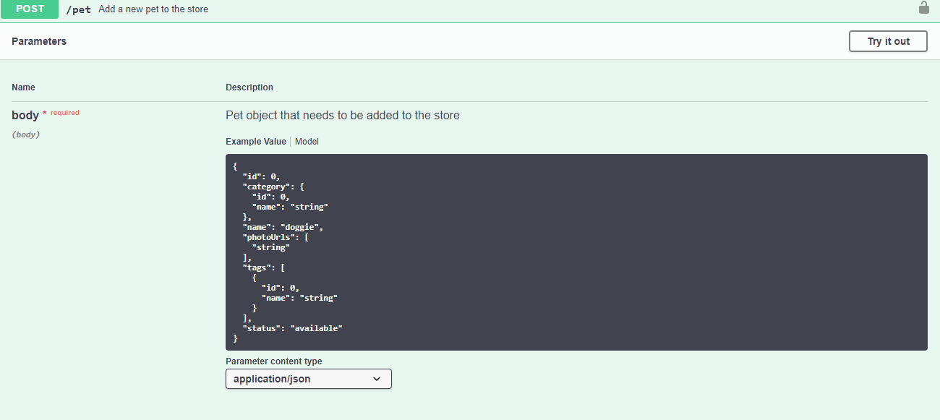

1. Click on Put
2. Provide Json/Xml payload
3. Click on Try it out

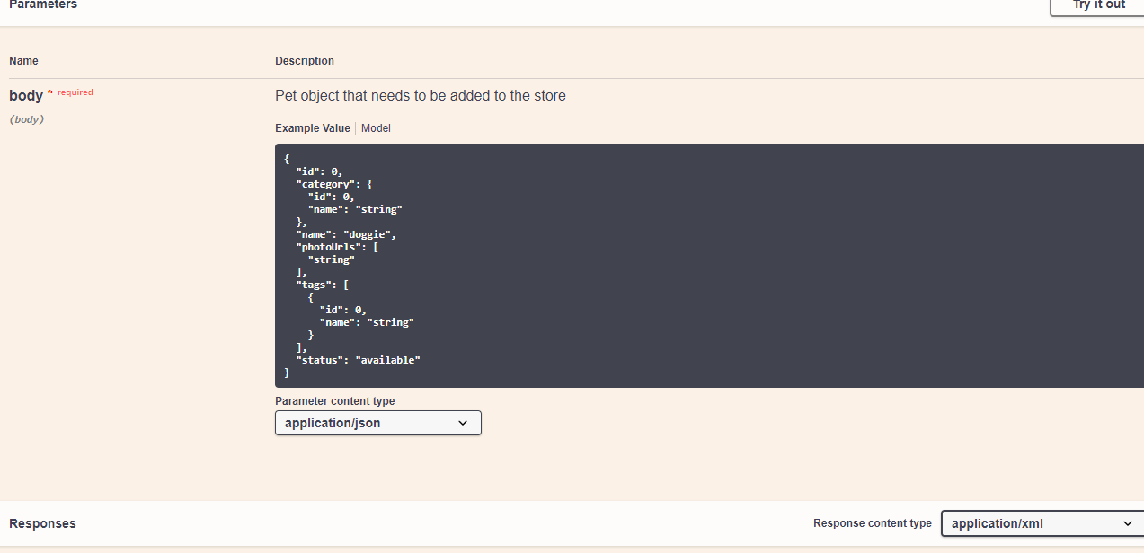

Similar for Get and Delete operations.